

# Hangman Game

**Project Report**

**Computer Organization & Assembly Language Section : B**

**Group Members:**

|  |  |
| --- | --- |
| **20K-0274** | **Nashit Budhwani** |
| **20K-0439**    **20K-1667** | **Muhammad Sameer Raza**  **Ashar Ur Rehman** |

**Hangman Game**

## Introduction

Hangman is a word-guessing game. One player picks a secret word, and the other player tries to guess it. The guessing player tries to guess the letters in the word. Each time they guess a letter correctly, the first player fills in the blanks for each occurrence of that letter. When the guessing player guesses a letter that isn’t in the word, they lose a point and the first player draws part of a stickman for each wrong guess. If the first player completes the stickman before the guessing player guesses the word, the guessing player loses.

## Background

Everyone is familiar with the infamous hangman game it's something that we have played since our childhood and something that we play to this day. We decided building a hangman in assembly language will give us a great understanding of this language as well as creating something that would be fun for us to use and show off. Speaking from a technical point of view, hangman was a great challenge as well because there were animations and logic to figure out if a word was correctly guessed or not. Choosing a word from a dictionary and input and output with the user. This was a good enough challenge for us and it really taught us the ins and outs of the Assembly language.

## Project Specification

The project consists of various functions that help to build hangman. Such as printing a stickman. Guessing words and etc.

## Features

Some features of the program are:

1. The console output of the program is presented in a neat and clean way.
2. Browsing through the user interface is easy and smooth.
3. The game is designed so that a word which has been asked, does not come up again, during a runtime.
4. The program uses many functions to make the transfer of control easier and hassle free.

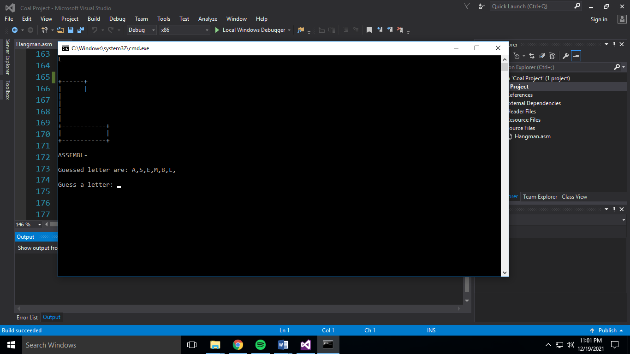

## RESULT AND CONCLUSION:

The project really helped us found greater insights into the working of assembly language and we also discovered new areas such as formation of library.

# Thank you